**A* Algorithm**

**Scenario:** Tomorrow, a girl named Mou will go to one of her friend’s houses for the 1st time. As she is going for the 1st time, she does not know the roads well. The Problem is There are several ways to go to her friend’s house. But she wants to go through the shortest way. Again, she has information on the minimum distance she has to cover if she chooses a specific way. Now help her on finding the shortest way to go to her friend’s house through coding.

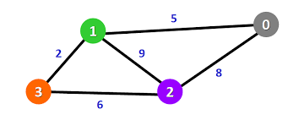

Figure: Path

Here 1 = source and 2= destination

**Decision tree**

**Scenario:** Joy is very choosy about food. For example, if food is given to him, he takes a decision if he would the food or not after analyzing various aspects like what is the meal type, how spicy the food is, etc. then he eats or avoid that food. But joy is not sure about the aspect which he should analyze firstly in case of choosing food or not. Now help joy to find the aspect which he should analyze firstly in case of choosing the food (Finding the root of the decision tree).

**Genetic Algorithm**

**Scenario:** Mita is a genetic engineer who is working on some chromosomes having 64 bonds. Her work includes crossover, mutation, etc. She wants to create a new feature for humans by working on chromosomes. For this, she needs a chromosome having 64 (A-T) type bonds (**in the code A-T bonds are denoted by 1 and C-G bonds are denoted by 0**). Now help her to find out the desired chromosome through coding.

Desired chromosome: 1111111111111111111111111111111111111111111111111111111111111111